**Request for Information #06-22**

**Gas to Energy Project – Marine Offloading Facility**

Distributed on: May 23, 2022

Response Requested by: June 10, 2022

**Esso Exploration and Production Guyana Limited (EEPGL)**

**1. Objective**

This Request for Information (RFI) seeks detailed commercial and technical information from Suppliers for meeting Esso Exploration and Production Guyana Limited (EEPGL) bid selection requirements for the design, procurement and construction of a Marine Offloading Facility (MOF) on the west bank of the Demerara River in Guyana, located in the region of Wales Estate directly east of the location for an Integrated Plant Site.

This RFI has the following key objectives:

* Identify Suppliers who can design, procure and construct the EEPLG - MOF at the required location with the following known and anticipated minimum requirements
* EEPGL is expected to use potential Supplier’s responses to validate and further develop EEPGL recommendations for inclusion in the Request for Proposal (RFP), therefore the RFI process provides for EEPGL to seek input and develop a list of qualified Suppliers (bidders).
* The RFI process provides the potential Suppliers an opportunity to begin developing responses to potential requirements in the event the Supplier is selected for the RFP.

EEPGL, at its sole discretion, may divide the services described in this RFI and in future RFP(s) into several enabling agreements that may be awarded to more than one Supplier.

This RFI does not imply any commitment by EEPGL, at this stage, to acquire goods or services from any Supplier. All expenses or costs incurred by any Supplier participating in the RFI and any subsequent RFP(s) shall be that of the Supplier only and not under any circumstances to EEPGL. Participation in the RFI does not guarantee an invitation to participate in an RFP.

**2. Background**

**General**

EEPGL intends to contract for the design, procurement and construction of a Marine Offloading Facility (MOF).

1. Anticipated MOF Requirements – all performance requirements below are preliminary and are an estimate of what bidders can expect in a RFP. Final performance requirements will be confirmed at a later time.
   * 1. Location – Along the west bank of the Demerara River as indicated in Figure 1.
     2. Dredging – The required minimum maintained water depth of 5.0 meters is expected to require initial and maintenance dredging to ensure there is an access channel, mooring basin and marine equipment turning area adjacent and connected to the MOF.
     3. Marine Equipment Capability – Safely mooring fully loaded cargo vessels (barges, tugs and ships) in the local marine environment of DWT approximately 2,000 to 10,000 DWT and physical dimensions of approximately 91.5m (~300 feet) in length by 30.5m (~ 100 feet) in beam by 6.0m (~ 20 feet) in depth, alongside or (as required) stern-to.
     4. Outfitting – A sufficient number and location(s) of marine equipment that meet marine industry standards necessary to safely / efficiently moor / unmoor marine vessels that will be offloading equipment, material, supplies, modules and personnel. This is expected to include but is not limited to fenders, bollards, bitts, chocks, kevels, cleats, line handling equipment and other marine equipment.
     5. Cargo Offloading – The facility shall be designed and capable of both roll-on / roll-off (RO/RO) and lift-on / lift-off (LO/LO) cargo operations.
     6. MOF Load Bearing Capacity – The minimum load bearing capacity is 10 metric tons / m².
     7. Adjacent Shore Side Offloading Area – The required adjacent offloading area and access to shore shall be a maximum width of 11 meters and capable of safely accommodating 2 each Self-Propelled Modular Transporters (SPMTs) transporting cargo up to 200 metric tons. The access way from the MOF to shore is required to have a minimum load bearing capacity of 8 metric tons / m² and ideally be a bridge-type access way that limits the environmental disturbance to the river bank.
2. Engineering, Procurement, and Construction Services
   * 1. Engineering Services
        1. Professional Engineering - Provide all services to design the MOF (See Figure 2 – Information Only) and this may include obtaining field geotechnical and metocean (tides, currents, waves, winds) data, if required, to support the design.
        2. Test / Verification Reports - Provide test reports, such as compaction tests, piling tests, and plate load testing to ensure the load bearing capacity of the facility is achieved as per design requirements.
        3. Applicable Codes / Standards – This shall include but are not limited to:
           1. ACI 318-19: Building Code Requirements for Structural Concrete and Commentary
           2. BS 6349: Maritime Structures – Code of Practice for General Criteria
           3. Mooring Equipment Guidelines (MEG4) by Oil Companies International Marine Forum (OCIMF)
           4. PIANC (World Association for Waterborne Transport Infrastructure) applicale guidelines
        4. Design life of estimated 25 years
     2. Procurement Services – Procure locally and globally sourced equipment and materials to construct and outfit the MOF
     3. Construction Services – Perform construction services that include but are not limited to:
        1. Site clearing, grading and compaction
        2. Dredging works
        3. Construction of the designed facility, including all piling and foundation works
        4. Installation of all MOF and quayside accessories, including, but not limited to mooring equipment, winches, fenders, and other support structures
3. EEPGL will provide the following for the RFP phase:
   1. Bathymetry reports
   2. Nearby onshore (not in the riverbed) geotechnical borehole data
   3. Major project regulatory permits / approvals (EPA Permit, Sea Defense No Objection, MARAD No Objection) will be obtained by EEPGL
   4. Contractor will be responsible for the construction phase working-level permits and approvals. These include, but are not limited to the following:
      1. MARAD permit for dredging
      2. Authorization to pass the Demerara Harbour Bridge
      3. Vessel authorizations
      4. Permits for vessel / equipment fueling, refueling, & temporary fuel storage (if onsite storage is planned)
      5. Any design-specific or construction-specific condition requirements of EEPGL’s EPA Permit / Sea Defense No Objection

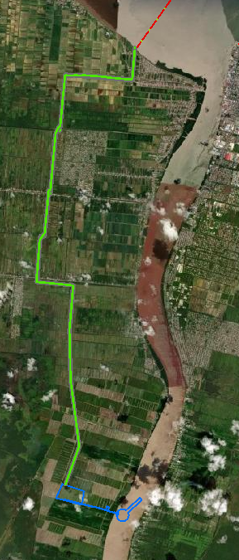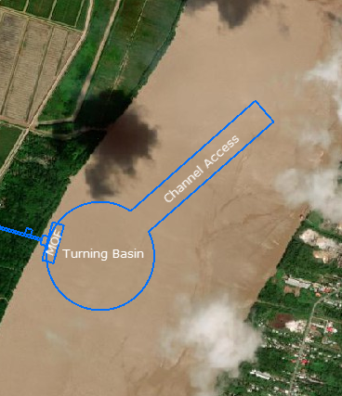

**Figure 1 -** Indicative of Preliminary Engineering - Information Only

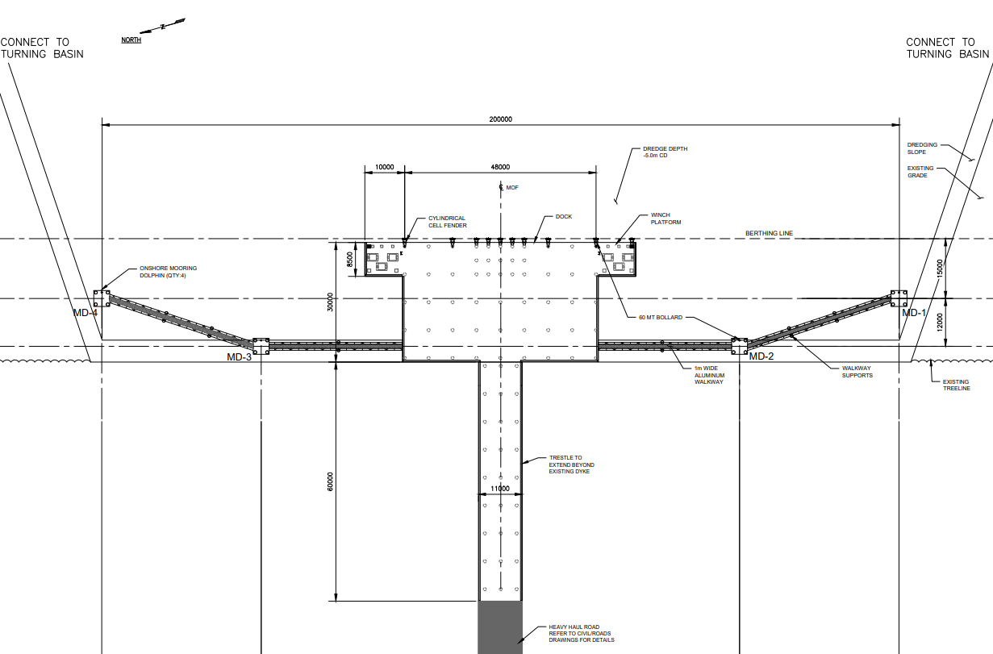

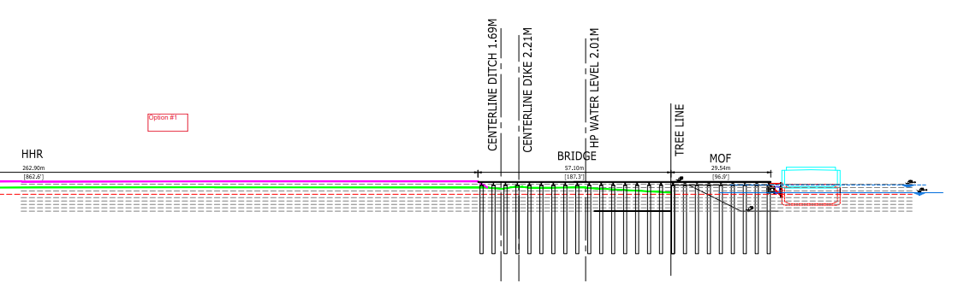

**Figure 2:** Indicative of Preliminary Engineering - Information Only

**3. Local Content Requirements**

3.1 EEPGL’s local content strategy is important to our business. Its elements are integrated into our daily processes and procedures, and guide the way we work today and plan for tomorrow.

3.2 Using a multi-tiered approach, EEPGL focuses on building workforce and supplier capabilities in conjunction with strategic investments in the local community.

3.3 During the bid process, all prospective EEPGL contractors are required to demonstrate awareness of the Local Content Act (2021) and its potential application to their work under the scope.

3.4 Bidders are expected to include in their submission a preliminary local content strategy outlining how they will deliver on the local content expectations outlined below and those captured in the Act, and, upon award, implement an acceptable plan. Should the successful bidder be required to submit local content plans to the Government of Guyana under the Local Content Act (2021) they will also provide a copy of those plans to EEPGL.

3.5 The following requirements apply to orders that will be performed, or with exercise of contractor’s best efforts could be performed, wholly or in any part in Guyana (including without limitation the Guyana Exclusive Economic Zone) or with utilization of any Guyanese subcontractor, vendor, or similar Guyanese content.

3.6 The below requirements specific to EEGPL contractors are in addition to the Local Content Act (2021) issued by the Government of the Cooperative Republic of Guyana; in the event of a conflict between these requirements and those of the Government of Guyana explicit instruction must be sought by EEPGL.

**REQUIRED ACTIVITIES**:

A. Contractor Procurement Activities:

To support EEPGL’s objectives of giving preference to qualified local suppliers from Guyana:

* + - * 1. Give fair and adequate opportunity and first consideration to the following:

The purchase of Guyanese goods and materials, provided such goods and materials are available on a timely basis of the quality and in the quantity required by the contractor at competitive prices.

Utilization of Guyanese contractors insofar as they are commercially competitive and satisfy the contractor's financial and technical requirements and meet the requirements of this section.

* + - * 1. Establish appropriate tender procedures for the acquisition of goods, materials, and services, which shall ensure that Guyanese contractors are given fair and adequate opportunity to compete for the supply of goods and services.
        2. Establish procedures to provide the contractor’s Guyanese subcontractors feedback following contracting activities.
        3. Ensure that the contractor’s subcontractors comply with the requirements contained in this section.
        4. Steward the contractor’s, and its sub-contractors’, local content development progress in accordance with these requirements and the contractor's local content plan.

B. Contractor’s Employment Opportunities

To support EEPGL’s objectives of giving preference to qualified local personnel and suppliers from Guyana, a contractor shall:

* + - * 1. Prepare and implement a program to give fair and adequate opportunity and first consideration for employment of Guyanese nationals having appropriate qualifications and necessary experience to perform job responsibilities commensurate with the contractor’s scope of work.
        2. Ensure that the contractor’s subcontractors comply with the requirements contained in this Section.
        3. Steward the contractor’s and its sub-contractors’ local content development progress in accordance with this guidance and the contractor's local content plan.

C. Contractor’s Use of External Resources:

1. Centre for Local Business Development

a. To facilitate transparent local hiring and contracting, a contractor is encouraged to consider using the following capabilities provided by the Centre for Local Business Development (CLBD):

Advertising upcoming vacancies and tenders with potential local content.

Publishing Vacancies/Expression of Interest/Tenders in the public domain for approximately two weeks via the Centre for Local Business Development Supplier Registration Portal (SRP) and CLBD Facebook/Website.

Utilize SRP to augment any bid lists with Guyanese contractors that meet requirements.

Plan communications for announcements of tender award/hiring/training as appropriate.

Provide opportunities for feedback following Expression of Interests/Request for Information (RFI) and bids to Guyanese vendors.

1. A contractor should also consider engaging, and actively collaborating with, the Centre for Local Business Development.

(i) The Centre’s role is to facilitate communication between suppliers, contractors and subcontractors, with a goal to build the capacity of Guyanese small and medium enterprises. The Centre will maintain a Supplier Registration Portal and is able to provide a mechanism for advertising opportunities for Guyanese goods and services, for a contractor’s use.

(ii) EEPGL does not endorse or recommend any supplier listed on the Portal. As such, a contractor should perform appropriate due diligence on any supplier prior to use. The Centre is located in Georgetown at 253-254 South Road, Bourda on the top floor of the IPED Building. The website is: [www.centreguyana.com](http://www.centreguyana.com)

2. Online & Social Media – Publishing Vacancies/Expression of Interest/Tenders in the public domain for approximately two weeks via relevant online and social media sites (EEPGL, Local Content Secretariat, contractor, and newspapers).

D. Contractor’s Local Content Metrics Reporting

* + - 1. A contractor shall provide local content reporting metrics using an EEPGL-provided template. The template may be updated by EEPGL at any time.
      2. Metric reporting requests will be sent at least twice annually to the contractor. EEPGL reserves the right to change the frequency of metric requests to the contractor.
      3. Should the contractor be required to submit metrics to the Government of Guyana under the Local Content Act (2021) they will provide a copy of those reports to EEPGL.

**4. RFI Instructions**

Please complete Section 7 - Questionnaire, elaborating on each item as appropriate and keeping the following in mind:

* Please use the attached spreadsheet for your response.
* Questionnaire should be completed in its entirety and submitted back in excel format with your company name in the file name.
* To avoid duplication of answers, you may reference other applicable sections of the questionnaire if the answer is already covered elsewhere.
* Please note the word limit for each section of the questionnaire. Submitters should not exceed the word limit.
* Additional attachments are permitted, but please only send if absolutely necessary. If you do send separate attachments to address any part of the questionnaire, please ensure the name of your file corresponds to the applicable section of the questionnaire.
* Please submit your response in **electronic** form using any of the following electronic formats: Microsoft Word, Microsoft Excel, Adobe PDF, etc.
* Your e-mailed responses should be limited to a reasonable size (<5MB). If the response is >5MB, then multiple submissions <5MB are acceptable.
* **Please do not submit pricing or price proposal information at this stage.**
* Your submittal should not include information which you consider proprietary, trade secrets or confidential.
* **There will be no clarification meetings for this RFI. Please submit all questions to email address:** [**EM.Guyana.Procurement@exxonmobil.com**](mailto:EM.Guyana.Procurement@exxonmobil.com)

**5. Due Date Schedule - Key Dates in the RFI/RFP Process**

Schedule

May 23, 2022 RFI to be issued through the Center for Local Business

Development

June 10, 2022 Deadline for supplier to submit completed RFI

June 2022 Evaluation of RFI responses

July 2022 Potential Commencement of RFP invitations

August 2022 Receipt / evaluation of RFP Proposals

October 2022 Potential contract award

**6. Submission of RFI with all complete documents**

* **All documents required to be submitted are due no later than 5:00 PM, June 10, 2022. No extensions will be granted.**

Contact for Questions please email: [EM.Guyana.Procurement@exxonmobil.com](mailto:EM.Guyana.Procurement@exxonmobil.com)

**How to Submit:**

1. Complete Required Documents and include in an email

1. Completed Questionnaire (Excel)
2. Completed PBAQ
3. Copy of the company’s Articles of Incorporation (including the page with the Directors/Management and details of nationality)
4. Copy of the company’s Certificate of Registration (company TIN) from the Guyana Revenue Authority
5. Copy of company’s organizational chart with details on nationality of all personnel’s.

2. Send Email with the following title format:

Your Company Name – RFI #06-22 Gas to Energy Project – Marine Offloading Facility (MOF) – Final RFI Submission

3. Send email to: [EM.Guyana.Procurement@exxonmobil.com](mailto:EM.Guyana.Procurement@exxonmobil.com)

* + - 1. Kindly note it’s not a requirement to register at the CLBD in order to respond to any of our RFI’s as this request is open to all interested companies.

**7. Questionnaire – See Separate Excel Spreadsheet**